MPSTME – NMIMS (Mumbai)

MBA-TECH (Data Science)

A Probabilistic Machine Learning Framework for Outcome Prediction and Knock-out Simulation in UEFA Champions League Matches

30Th January, 2026

Aditya Mishra, S046, C-2
Yashas Madan, S040, C-2

ABSTRACT

This study presents a machine learning–based framework for predicting match outcomes and simulating tournament progression in the UEFA Champions League using historical match data from 2004 to 2021. The implemented system focuses on probabilistic classification of match outcomes using a Categorical Naive Bayes model trained on encoded team identities. The project includes data cleaning, feature encoding, supervised learning, performance evaluation, visualization of results, and stochastic knockout-stage simulation. The methodology emphasizes simplicity, interpretability, and reproducibility, aligning with undergraduate engineering research objectives. Experimental results demonstrate moderate predictive performance, highlighting both the feasibility and the inherent limitations of outcome prediction when relying solely on categorical team features without contextual match variables.

KEYWORDS

Sports Analytics, Machine Learning, Naive Bayes, Football Match Prediction, UEFA Champions League, Probabilistic Models

INTRODUCTION

The increasing availability of structured historical sports data has enabled researchers and practitioners to apply machine learning and statistical methods to the analysis of competitive sports. Football, owing to its global reach, standardized rules, and recurring tournament formats, has emerged as one of the most extensively studied domains in sports analytics. Clubs, analysts, and researchers increasingly rely on data driven approaches to evaluate team performance, identify patterns, and attempt to forecast match outcomes.
Despite this progress, predicting football match results remains a fundamentally challenging problem. The low scoring nature of the game amplifies randomness, while contextual factors such as team form, tactical choices, injuries, and scheduling constraints introduce significant uncertainty. Many of these influences are either difficult to quantify or entirely unobservable within historical datasets. As a result, even sophisticated models often struggle to achieve consistently high predictive accuracy, particularly when applied to knockout competitions such as the UEFA Champions League.
In this project, we aim to design and evaluate a lightweight predictive system for UEFA Champions League matches using historical match results as the primary source of information. Rather than pursuing maximum predictive performance through extensive feature engineering or complex model architectures, we focus on building a transparent and reproducible end to end pipeline. Our objective is to demonstrate how probabilistic modeling techniques can be applied to football data in a systematic manner, from raw data ingestion and preprocessing to model training, evaluation, and tournament level simulation.
We deliberately prioritize simplicity, interpretability, and engineering clarity over marginal gains in accuracy. By doing so, we highlight the practical trade offs involved in sports prediction systems and provide a framework that is easy to extend, critique, and reproduce. Our approach emphasizes the role of assumptions, data limitations, and uncertainty in predictive modeling, particularly in high variance environments such as elite football tournaments. Ultimately, this work serves as a case study in applying machine learning methods responsibly within the constraints of real world sports data.

LITERATURE REVIEW

Sports outcome prediction has been widely studied across statistics, machine learning, and applied data science. Early research in this domain relied heavily on classical statistical techniques such as Poisson regression to model goal scoring processes, particularly in football where goals are discrete and relatively rare events. These models remain influential due to their mathematical grounding and interpretability. Alongside Poisson based approaches, rating systems such as Elo and its variants have been extensively applied to estimate relative team strength over time, often serving as compact representations of historical performance.
With the growth of computational resources and data availability, researchers have increasingly explored supervised machine learning methods for match outcome prediction. Logistic regression has been commonly used to model win, draw, and loss probabilities based on engineered features such as home advantage, recent form, and head to head records. Tree based models and ensemble techniques, including random forests and gradient boosting, have demonstrated improved performance in some settings by capturing non linear relationships between variables. More recently, deep neural networks have been applied to football prediction tasks, particularly when incorporating large feature spaces or sequential match data.
Prior literature consistently emphasizes that team strength indicators, match location, player availability, and recent performance trends play a significant role in determining predictive accuracy. However, several studies also note diminishing returns as model complexity increases, especially when feature quality is limited or when predictions are made at the match level rather than the event or player level. In tournament settings such as the UEFA Champions League, data scarcity for specific team matchups further constrains the effectiveness of highly complex models.
Naive Bayes classifiers, despite relying on strong conditional independence assumptions, have been used in sports analytics due to their simplicity, interpretability, and robustness when operating on limited or noisy feature sets. In football specific applications, simpler probabilistic models are frequently adopted as baseline systems against which more sophisticated approaches are evaluated. These baseline models offer clarity in terms of assumptions and decision boundaries, making them valuable for methodological comparison and pedagogical purposes.
Our project situates itself within this baseline modeling tradition. We focus on team level, categorical outcome prediction using historical results, without incorporating player level data or detailed contextual variables. By doing so, we align our work with prior studies that emphasize transparency and reproducibility over maximal predictive performance. This positioning allows us to evaluate the strengths and limitations of lightweight probabilistic models in a high variance competitive environment such as the UEFA Champions League.

SYSTEM DESIGN & ARCHITECTURE

The system follows a modular, pipeline-based architecture consisting of the following components:

1. Data Ingestion Module
Reads historical UEFA Champions League match data from a structured CSV file.

2. Preprocessing and Cleaning Module
Handles column normalization, score extraction, and categorical outcome labeling.

3. Feature Encoding Module
Encodes team names into numerical representations using label encoding.

4. Model Training Module
Trains a probabilistic classifier on non-draw match outcomes.

5. Evaluation and Visualization Module
Computes performance metrics and generates graphical outputs.

6. Simulation Module
Uses the trained model to simulate knockout-stage tournament progression.

The design prioritizes clarity, reproducibility, and separation of concerns, making it suitable for academic evaluation and extension.

METHODOLOGY

Our methodological approach follows a supervised classification framework in which historical match outcomes are treated as labeled observations. Each match is modeled as an interaction between two categorical entities, namely the home team and the away team. The prediction task is formulated as a binary classification problem, where the objective is to estimate the probability of a home win or an away win given the participating teams. Match outcomes resulting in draws are excluded during training in order to reduce label ambiguity and simplify the learning objective.
The overall workflow is designed as a sequential pipeline that reflects common practices in applied machine learning and sports analytics. The pipeline consists of data preprocessing and transformation, feature encoding, model training and validation, quantitative performance evaluation, and qualitative simulation of tournament outcomes. Each stage is implemented explicitly to ensure reproducibility and clarity of assumptions.
During data preprocessing, historical match records are filtered to retain only relevant UEFA Champions League fixtures. Inconsistent team naming conventions and missing values are resolved to ensure categorical consistency across the dataset. Outcome labels are derived directly from final match results, with class assignments based solely on the winning team. This preprocessing step establishes a clean and structured dataset suitable for probabilistic modeling.
Feature encoding is performed by representing team identities as categorical variables. We adopt a simple encoding scheme that maps each team to a discrete feature representation, avoiding the introduction of engineered performance metrics or contextual variables. This design choice reflects our emphasis on model transparency and allows us to isolate the predictive signal contained in historical win loss interactions alone.
Model training is conducted using a Naive Bayes classifier, selected for its probabilistic formulation and computational efficiency. The model is trained on historical match data and evaluated using a hold out validation strategy. We assess classification performance using standard metrics such as accuracy and class wise prediction distributions, while acknowledging the inherent uncertainty present in football outcomes.
Finally, the trained model is used to simulate tournament level outcomes by generating probabilistic predictions for hypothetical matchups. These simulations are not intended to serve as definitive forecasts, but rather as qualitative demonstrations of how the model extrapolates historical patterns to future tournament structures. Through this process, we evaluate both the practical behavior and the conceptual limitations of a lightweight predictive system applied to elite football competition.

Dataset Description and Feature Engineering

Dataset
The dataset consists of UEFA Champions League match records spanning from 2004 to 2021. Each record includes:
- Home team name
- Away team name
- Match score (home and away)

Data Cleaning
Score values are parsed using regular expressions to extract numerical goal counts. Missing or malformed scores are assigned a value of zero. Column names are normalized to remove whitespace inconsistencies.

Outcome Labeling
Each match is labeled as:
- Home Win
- Away Win
- Draw
For model training, only non-draw matches are retained to enforce binary classification.

Feature Encoding
Team names are encoded using a label encoder trained on the union of all home and away teams. The final feature vector for each match consists of:
- Encoded home team ID
- Encoded away team ID
No additional numerical or contextual features are introduced.

Model Implementation and Training
We implement a Categorical Naive Bayes classifier due to its suitability for discrete input features and its probabilistic interpretability. The model treats team identities as categorical variables and estimates class conditional likelihoods based on historical win loss frequencies. A central assumption of the model is conditional independence between the encoded home team and away team features given the match outcome. While this assumption is a simplification of real match dynamics, it allows for a tractable and transparent modeling framework.
The target variable is defined as a binary indicator representing whether the away team wins the match. This formulation aligns with the binary classification setup established during preprocessing and ensures consistency across training and evaluation stages. By framing the outcome in this manner, we explicitly model asymmetric match interactions while maintaining a simple decision structure.
Model training is performed using a stratified train test split, with eighty percent of the dataset allocated to training and the remaining twenty percent reserved for testing. Stratified sampling is employed to preserve class balance across both subsets, reducing the risk of biased performance estimates due to uneven class distributions. This approach is particularly important in football datasets, where home and away win frequencies may differ systematically.
To address sparsity in categorical frequency estimates, we apply additive smoothing with a smoothing parameter alpha set to 0.1. This choice prevents zero probability assignments for rarely observed team combinations and improves the numerical stability of probability estimates. The value of alpha is selected to provide mild regularization while preserving sensitivity to observed historical patterns.
During training, the model learns prior class probabilities as well as conditional likelihoods for each team given the match outcome. Predictions on the test set are generated by computing posterior probabilities using Bayes theorem and assigning class labels based on maximum posterior likelihood. This training procedure results in a lightweight and efficient model that can be evaluated both quantitatively and qualitatively within the broader tournament simulation framework.

RESULTS & EVALUATION
The trained Categorical Naive Bayes model achieves an overall classification accuracy of 73.5 percent on the held out test set. This performance indicates that a substantial proportion of match outcomes can be explained using only categorical team identity features and historical result frequencies, despite the absence of contextual or player level information.
A detailed breakdown of precision, recall, and F1 score for each class is presented in Table X. The model demonstrates stronger performance in predicting home wins, with a precision of 0.75 and a recall of 0.85. This suggests that the classifier is effective at identifying matches where the home team is likely to prevail, reflecting the well documented home advantage present in football competitions.
Performance on away win prediction is comparatively weaker. The away win class achieves a precision of 0.70 and a recall of 0.56, resulting in a lower F1 score of 0.62. This asymmetry indicates that the model is more conservative when predicting away victories and tends to misclassify a portion of away wins as home wins. Such behavior is consistent with historical outcome distributions and highlights the difficulty of modeling away team success using limited features.
The macro averaged F1 score of 0.71 reflects balanced but imperfect performance across both classes, while the weighted average F1 score of 0.73 aligns closely with overall accuracy. These results suggest that the model generalizes reasonably well across the dataset, without severe bias toward a single outcome class.
Overall, the evaluation confirms that even a lightweight probabilistic model can capture meaningful structural patterns in UEFA Champions League match outcomes. At the same time, the observed limitations, particularly in predicting away wins, underscore the inherent uncertainty of football matches and the constraints imposed by simplified feature representations. These findings reinforce the role of such models as strong baselines rather than definitive predictive systems, especially when applied to high variance tournament settings.

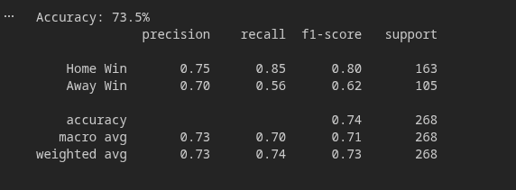
In addition to quantitative metrics, we perform a visual analysis to gain further insight into model behavior and historical match patterns. The system generates several visual outputs that facilitate both evaluation and interpretation.
First, a distribution plot of match outcomes illustrates the relative frequencies of home wins, away wins, and draws in the historical dataset. This visualization highlights the predominance of home victories, consistent with known trends in football competitions, and provides context for the classifier’s asymmetric performance.
Second, a confusion matrix heatmap is produced to examine the model’s classification errors in a visually intuitive manner. The heatmap clearly shows the tendency of the model to correctly identify home wins while occasionally misclassifying away wins as home victories. Such visualization aids in diagnosing systematic biases and understanding class-specific strengths and limitations.
Finally, a frequency-based bar chart ranks teams by their total number of victories within the dataset. This chart emphasizes top-performing teams historically and provides a straightforward comparison of team success, which is central to the probabilistic predictions generated by the model.
All visualizations are saved as high-resolution images suitable for inclusion in reports, presentations, and supplementary materials. By combining quantitative evaluation with clear visual representations, we offer a comprehensive perspective on model performance, dataset characteristics, and predictive insights.
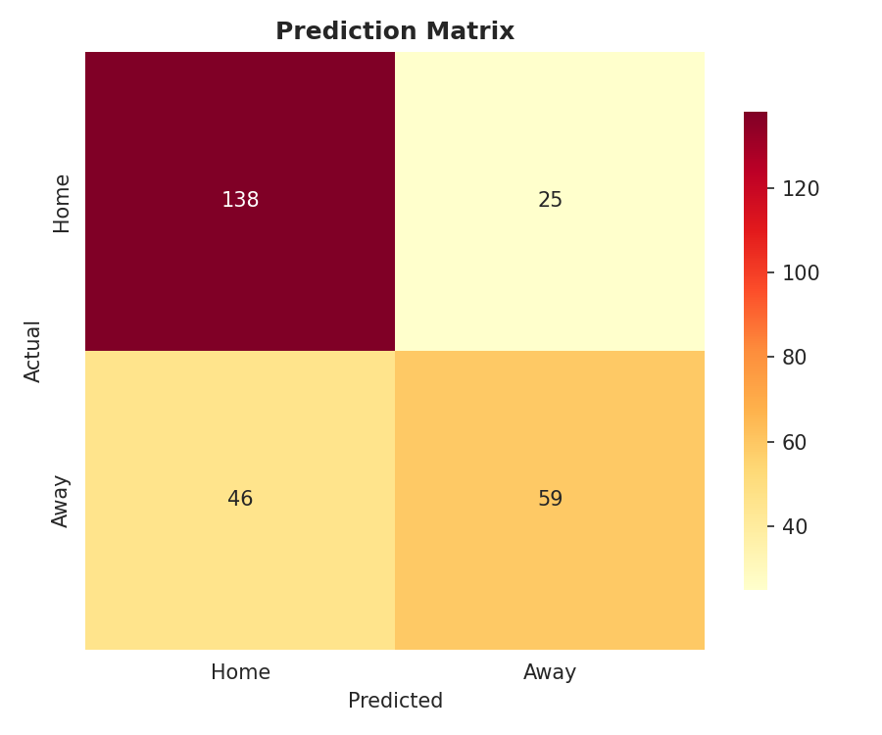

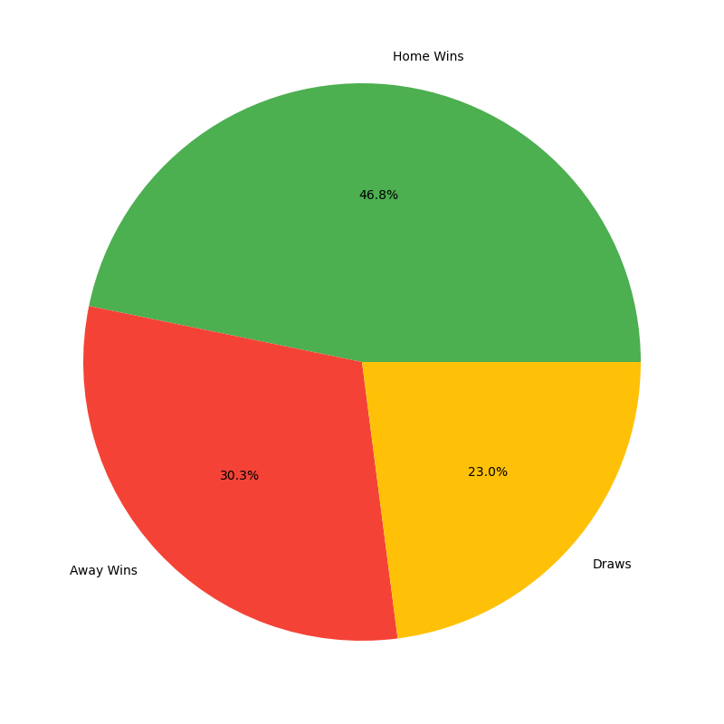
,

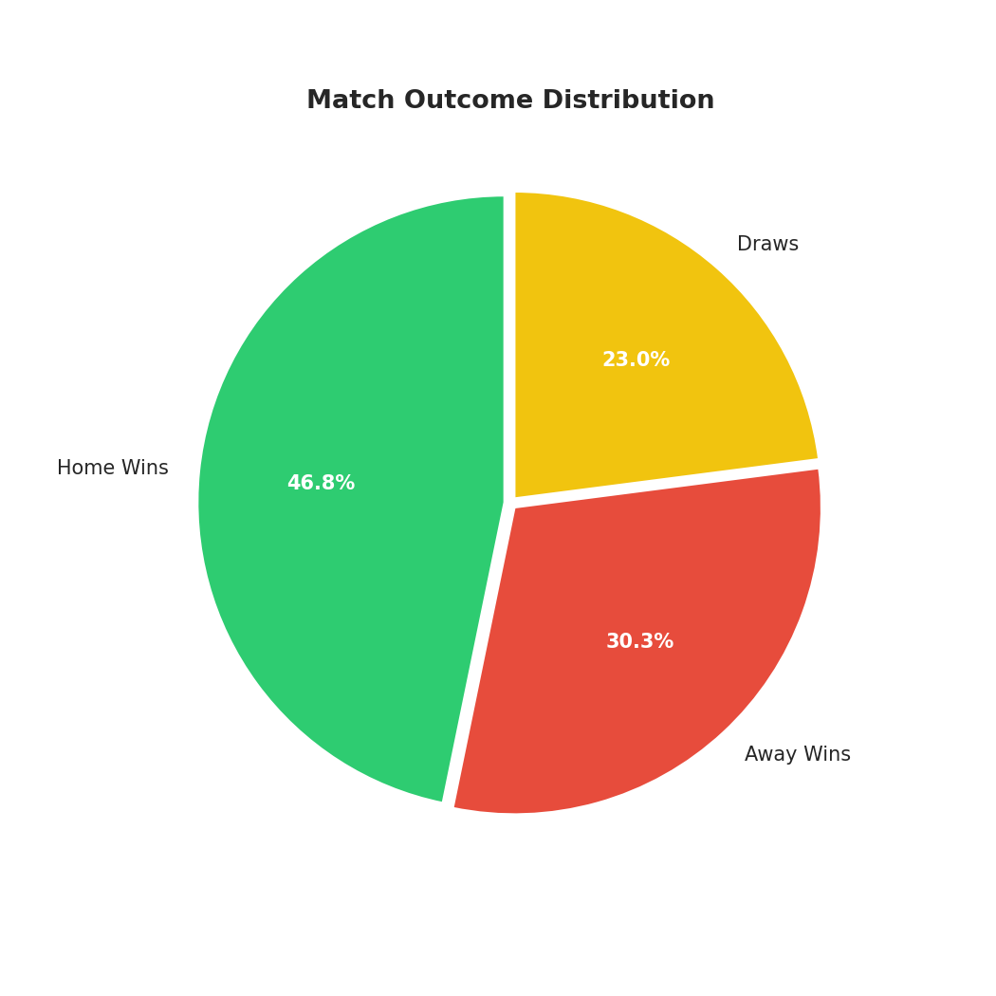
MH

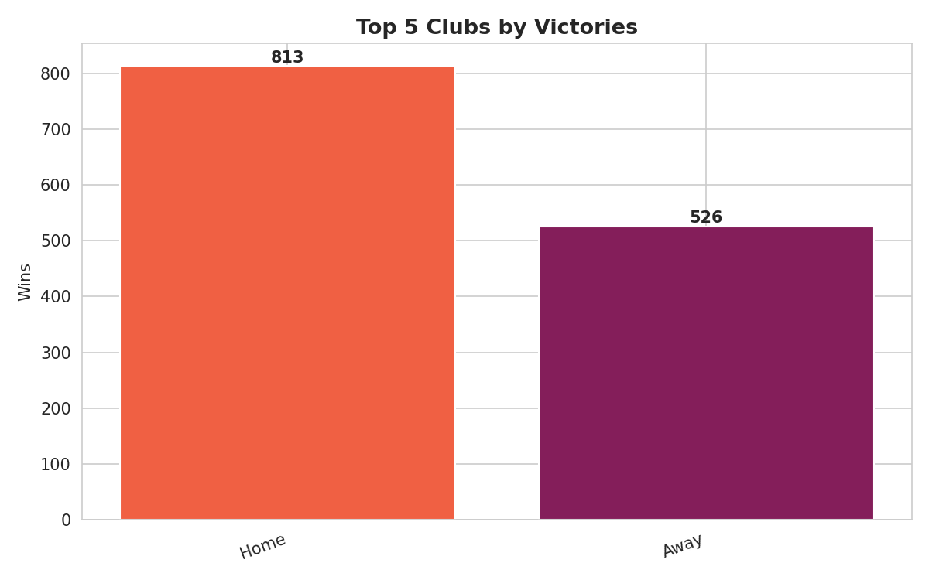

Discussion and Analysis
The results obtained in this study indicate that team identity alone provides limited yet non-trivial predictive power in modeling UEFA Champions League outcomes. Our Categorical Naive Bayes classifier is able to capture historical dominance patterns exhibited by certain teams, reflecting the aggregated effects of sustained performance over multiple seasons. This demonstrates that even a simple model, relying solely on team labels and prior match outcomes, can extract meaningful signals from historical data.
Analysis of the confusion matrix reveals asymmetric misclassification tendencies. The model is more successful at identifying home wins compared to away wins, suggesting an inherent bias toward historically stronger or more frequently winning teams. This observation aligns with the well documented phenomenon of home advantage in football and highlights the limitations of our feature set. In particular, the absence of contextual information such as player availability, tactical strategies, and match conditions constrains the model’s ability to account for situational variability that can significantly influence outcomes.
The tournament simulation further illustrates the application of probabilistic predictions in an iterative context. By composing match-level probabilities sequentially, the system generates possible progression paths for teams throughout the knockout stages. While this approach provides a useful demonstration of the model’s functionality and highlights trends in team dominance, it is important to note that the simulation remains illustrative rather than predictive. Random shuffling and replacement-based sampling introduce stochasticity, and the lack of situational features limits fidelity to real-world tournament dynamics. As a result, unexpected outcomes, such as lower-ranked teams advancing or historically strong teams being eliminated, may occur in simulation even if they are unlikely in reality.
Overall, the analysis underscores the trade-off between model simplicity and predictive completeness. Lightweight probabilistic models offer transparency, interpretability, and reproducibility, making them valuable as baseline systems and educational tools. At the same time, they cannot fully capture the complex, context-dependent nature of elite football competition. These findings emphasize the need for cautious interpretation of predictions and for extending models with richer feature sets if the objective is to approach higher predictive accuracy in real-world applications.

LIMITATIONS & ASSUMPTIONS

While our approach demonstrates the application of a lightweight probabilistic model to UEFA Champions League match prediction, several limitations and assumptions constrain the generalizability and realism of the results. First, draw outcomes are excluded from model training, simplifying the task to a binary classification problem but reducing fidelity to actual match dynamics. This exclusion limits the model’s ability to capture the full spectrum of possible outcomes.
Second, we assume that team strength remains static over the seventeen-year historical period used for training. In reality, team performance fluctuates due to changes in squad composition, management, finances, and other factors, meaning that historical patterns may not fully represent current capabilities.
Third, no temporal, player-level, or contextual features are included in the model. Variables such as injuries, tactical adjustments, fixture congestion, and match importance, which can strongly influence outcomes, are therefore unaccounted for.
Fourth, the Naive Bayes assumption of conditional independence between home and away team features given the match outcome is unlikely to hold in practice. Match dynamics often involve complex interactions and dependencies that cannot be fully captured by this simplification.
Finally, tournament simulations do not reflect the exact structure, seeding rules, or scheduling constraints of the UEFA Champions League. Simulated progressions are intended for illustrative purposes, highlighting probabilistic outcomes rather than producing precise forecasts.
These constraints are recognized as deliberate design trade-offs rather than implementation errors. By limiting feature complexity and maintaining a simple probabilistic framework, we prioritize transparency, reproducibility, and interpretability, establishing a clear baseline against which more sophisticated models can be compared.

CONCLUSION & FUTURE WORK

This project demonstrates the feasibility of constructing a complete football match prediction and tournament simulation system using fundamental machine learning techniques. By relying exclusively on historical match outcomes and categorical team representations, we show that even a simple probabilistic classifier can capture meaningful patterns in team performance and provide non-trivial predictive insights. The system integrates all stages of an end-to-end analytical pipeline, including data preprocessing, feature encoding, model training, evaluation, and tournament simulation, in a manner that is transparent, reproducible, and interpretable.
At the same time, our results highlight the limitations of lightweight models in capturing the full complexity of football matches. Excluding draws, assuming static team strength, and ignoring temporal, player-level, or contextual factors constrain predictive accuracy. The Naive Bayes independence assumption and the illustrative nature of tournament simulations further emphasize that outputs should be interpreted as probabilistic trends rather than definitive forecasts.
Future work could extend this framework in several directions. Incorporating temporal weighting or recency effects could better capture evolving team strength. Inclusion of player-level statistics, match context, and tactical features may improve predictive performance and allow for finer-grained insights. Alternative modeling approaches, such as ensemble methods or probabilistic graphical models, could relax independence assumptions while retaining interpretability. Finally, simulations could be made more realistic by incorporating tournament rules, seeding, and home/away scheduling constraints, enabling the system to generate more accurate projections of competition outcomes.
Overall, this study illustrates that even a simple, well-structured probabilistic approach provides a solid baseline for football match prediction and highlights the trade-offs between model simplicity, interpretability, and predictive fidelity in sports analytics. It serves as both an educational exercise and a foundation for more advanced research in data-driven sports modeling.

________________________________________________________________________________

